
Billing Authorization Form
Membership payments are due the first of the month. The payment will be collected via bank draft (preferred due to lower fees) or credit card. Sales tax is collected as required by law.

Account Name: ___________________________ Contact Phone #:_________________
$300.00 Initiation fee will be added to the 1st month billing:
Community Membership Monthly - $140/month plus sales tax
Full Golf Membership Monthly - $255/month plus sales tax
Junior Membership (Under 30) - $170/month plus sales tax
Out of Parish Weekly Membership - $170/month plus sales tax
Range Plan - $20.00/month plus sales tax
$500.00 Initiation fee will be added to the 1st month billing
Pool and Pickleball/Tennis Membership (April-October) - $185/month plus sales tax

Payment Method - Fill out either Bank Draft or Credit Card Information.
The Bank Draft is the preferred method of payment due to its lower fees. NOTE *** If using a credit card, the fees associated with your card will be added to your monthly dues amount.
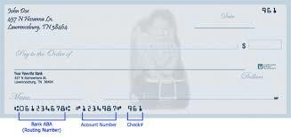

Routing Number

Account Number

Bank Draft Information
Name of Bank: ___________________________ Routing Number: __________________
Account Number: __________________ Circle those that apply (Personal/Business, Checking/Savings)
Credit Card Information
Credit Card Type: Circle: American Express, Visa, Mastercard, Discover
Name on Card: _____________________________ Credit Card # _______________________________
Expiration Date: ____________________________ Three or four digit code on back: ________________
Authorization Signature of Applicant: _______________________________________Date:____________

